**NEPAL COLLEGE OF INFORMATION TECHNOLOGY**

**Balkumari, Lalitpur**



**A Lab Report**

**On**

**Subject:- Web Technology**

**Lab Report # _5__.**

**Title: - Form & login Box**

**Submitted by:- Submitted to:-**

**Name : - Abiral Chaudhary Instructor: - Simanta Kasaju**

**Roll No:- 221702 Department :- software**

**Faculty: - science and technology Submission Date:2080/03/28**

**Semester:-II**

**Form**

<form> is an HTML element to collect input data containing interactive

controls. It provides facilities to input text, number, values, email,

password, and control fields such as checkboxes, radio buttons, submit

buttons, etc., or in other words, form is a container that contains input

elements like text, email, number, radio buttons, checkboxes, submit

buttons, etc. Forms are generally used when you want to collect data from

the user. For example, a user wants to buy a bag online, so he/she has to

first enter their shipping address in the address form and then add their

payment details in the payment form to place an order.

Forms are created by placing input fields within paragraphs, preformatted

text, lists and tables. This gives considerable flexibility in designing the

layout of forms.

Syntax:

<form>

........................................

</form>

**Form elements**

These are the following HTML <form> elements:

• **<label>:** It defines a label for <form> elements.

• **<input>**: It is used to get input data from the form in various types

such as text, password, email, etc by changing its type.

• **<button>:** It defines a clickable button to control other elements or

execute a functionality.

• **<select>**: It is used to create a drop-down list.

• **<textarea>:** It is used to input long text content.

• **<fieldset>**: It is used to draw a box around other form elements and

group the related data.

• **<legend>:** It defines a caption for fieldset elements.

• **<datalist>:** It is used to specify predefined list options for input

controls.

• **<output>:** It displays the output of performed calculations.

• **<option>:** It is used to define options in a drop-down list.

• **<optgroup>:** It is used to define group-related options in a drop-

down list.

**Table**

An HTML table is defined with the “table” tag. Each table row is defined

with the “tr” tag. A table header is defined with the “th” tag. By default,

table headings are bold and centred. A table data/cell is defined with the

“td” tag.

Example

<H1>A basic HTML table</H1>

<table border="1">

<tr>

<th>Company</th>

<th>Contact</th>

<th>Country</th>

</tr>

<tr>

<td>Alfreds Futterkiste</td>

<td>Maria Anders</td>

<td>Germany</td>

</tr>

<tr>

<td>Centro comercial Moctezuma</td>

<td>Francisco Chang</td>

<td>Mexico</td>

</tr>

</table>

Output

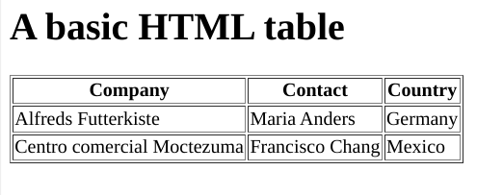

**Question 1**

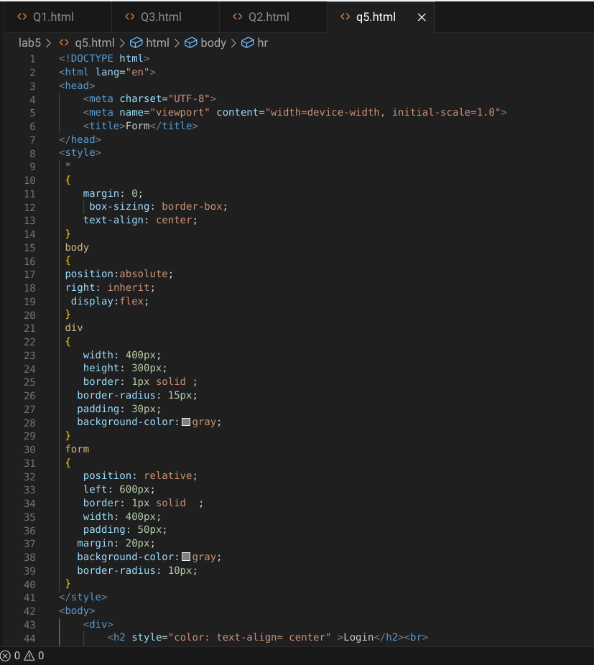

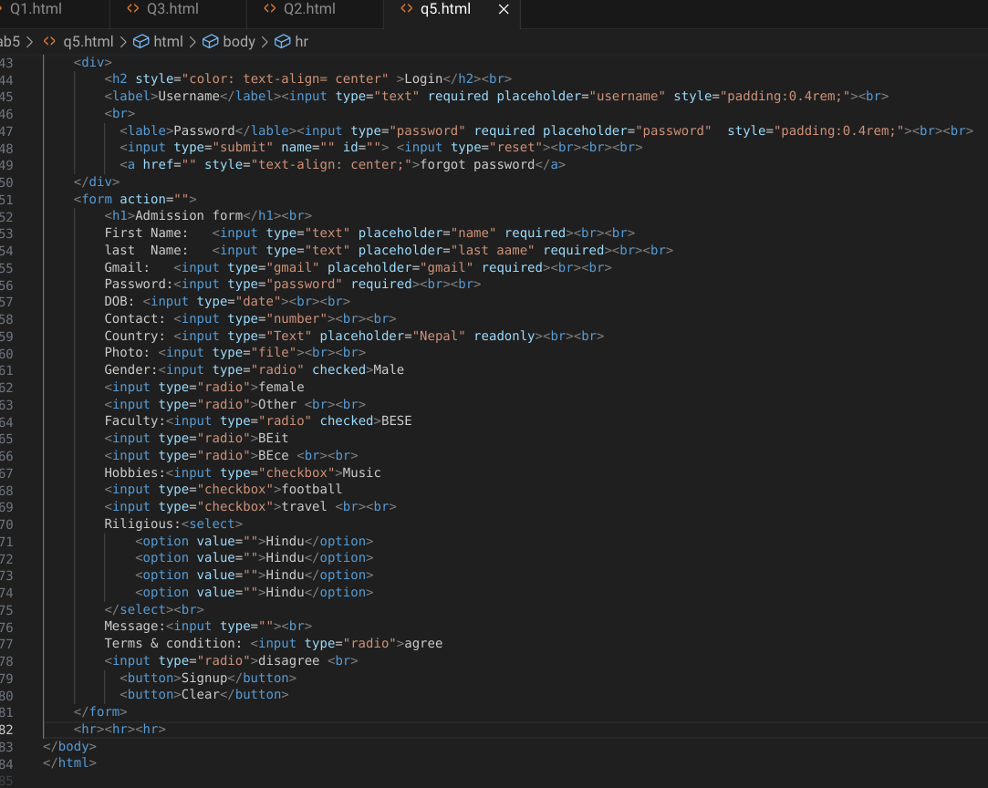

**Output:**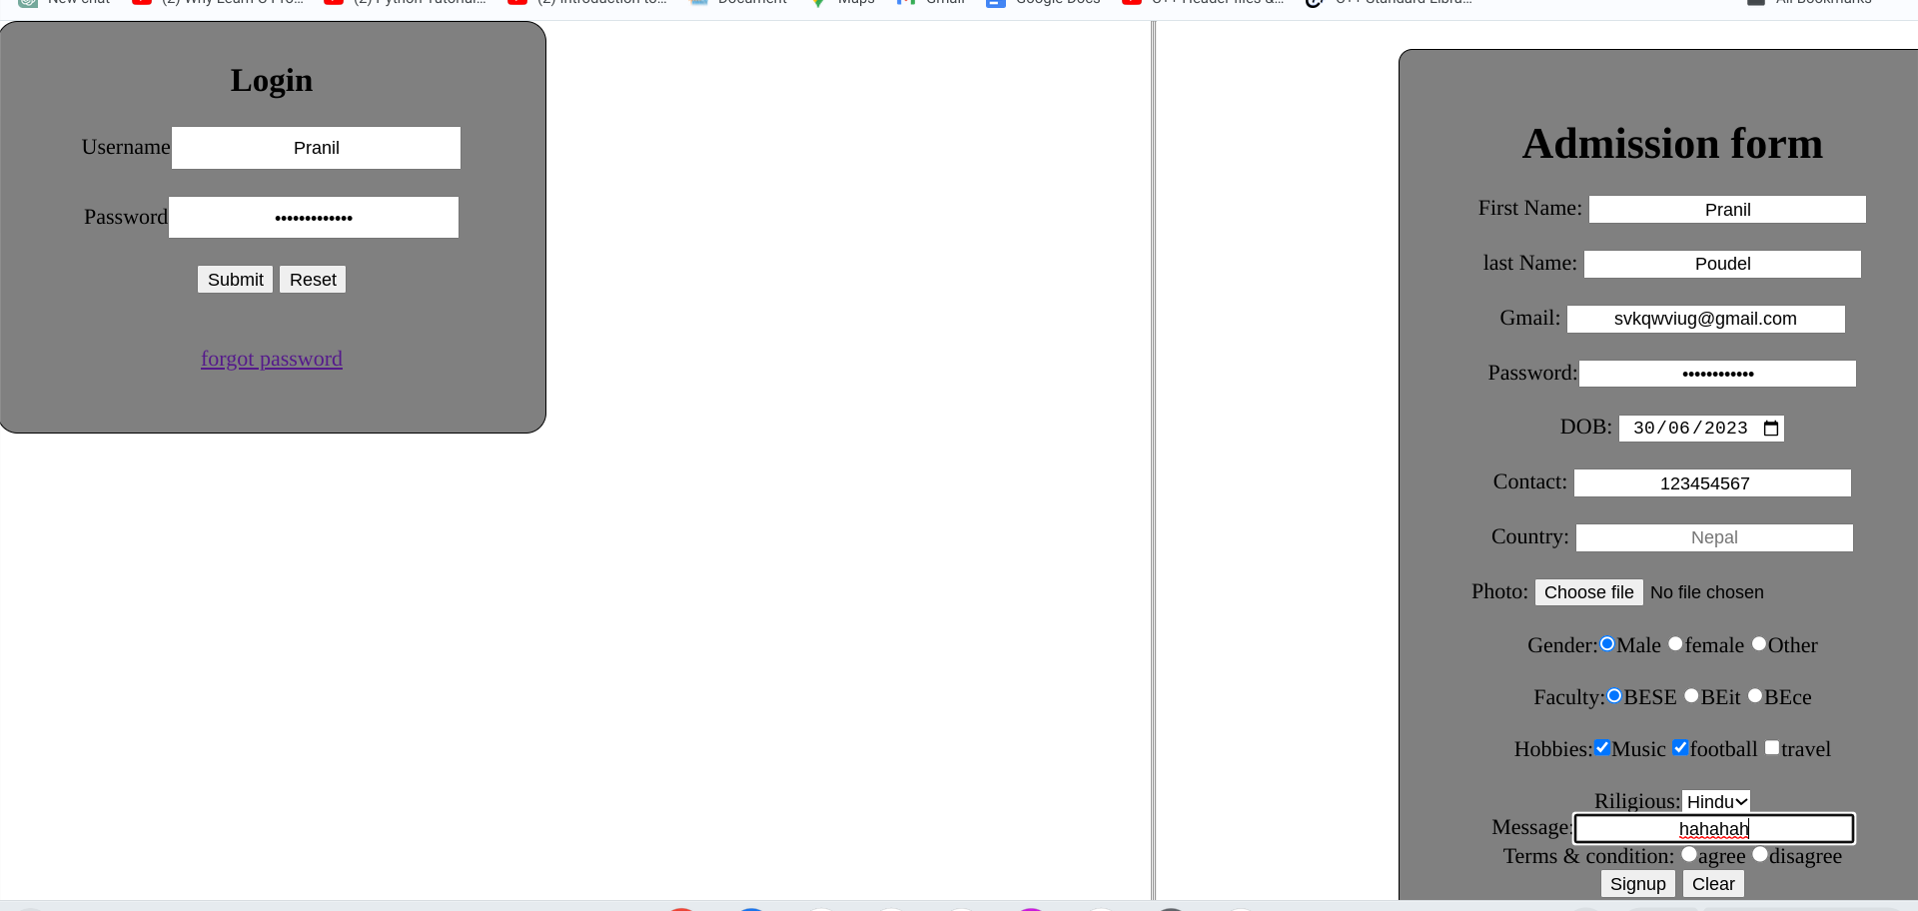

**Question 2**

**a)**

**Code :**

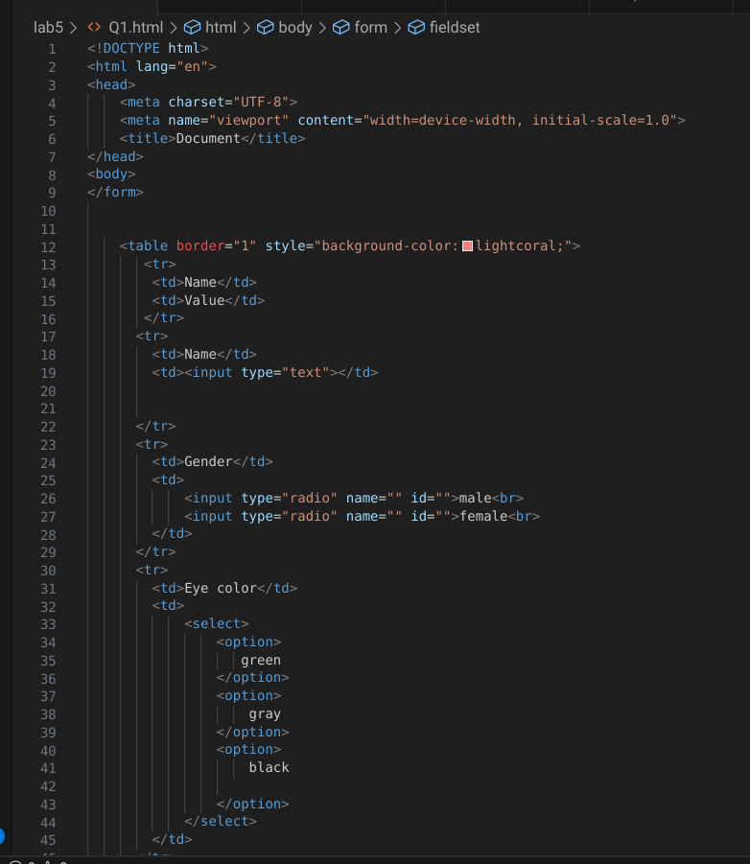

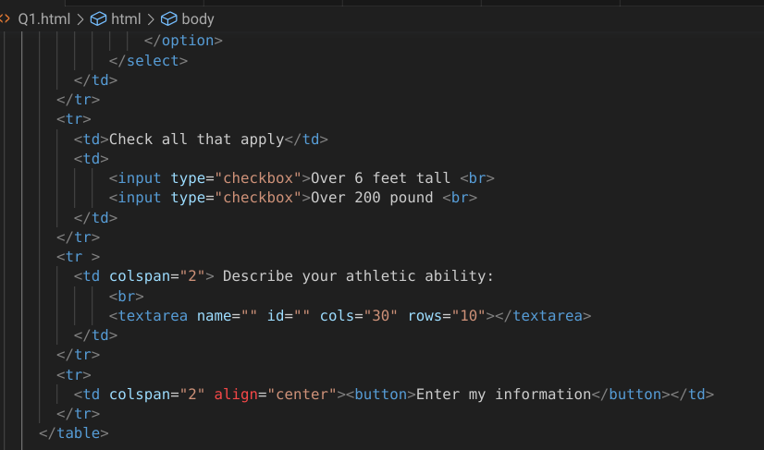

**Output:**

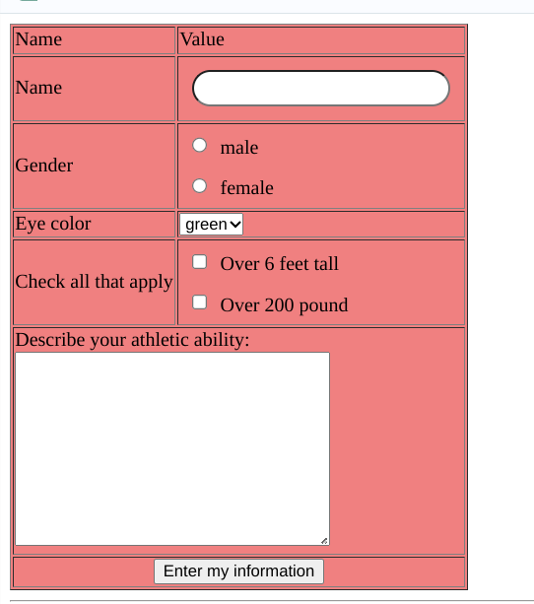

**B)**

**code:**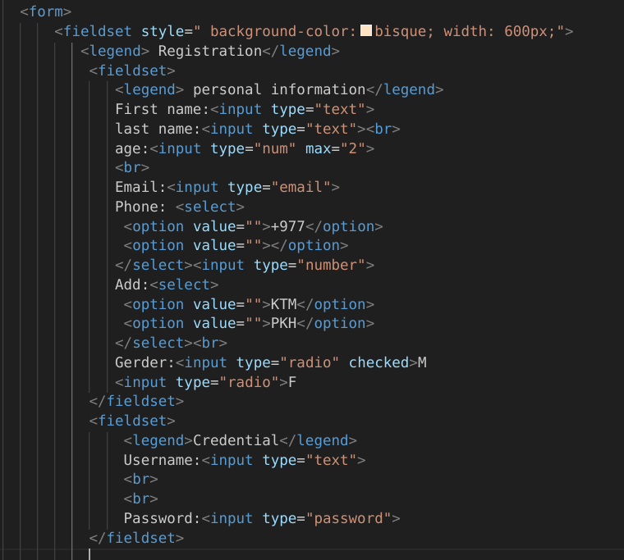

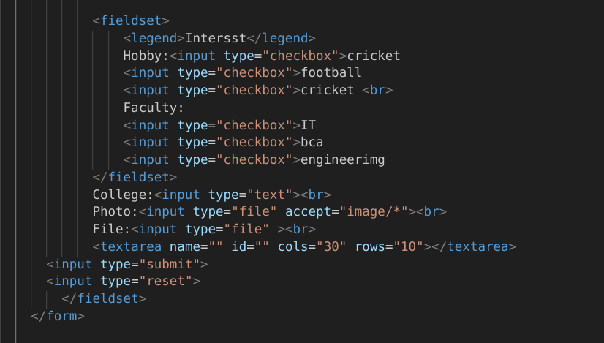

**Output:**

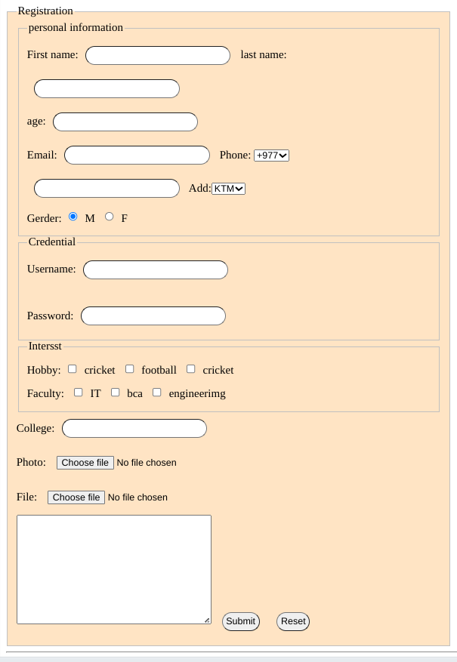

**c)**

**Code:**

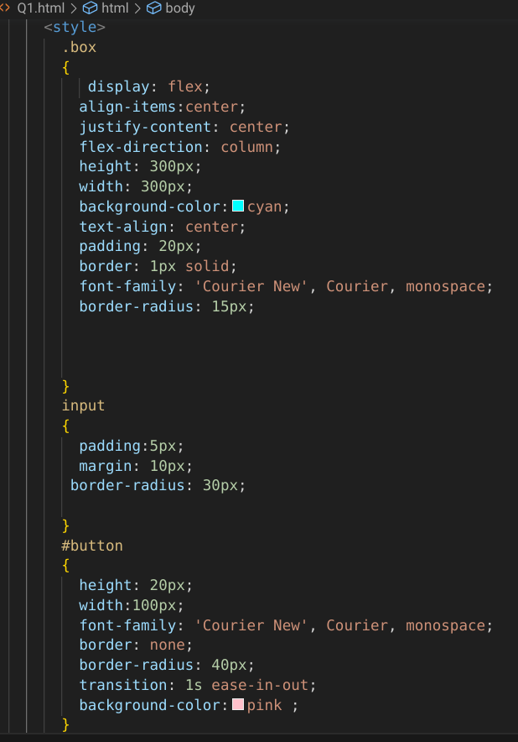

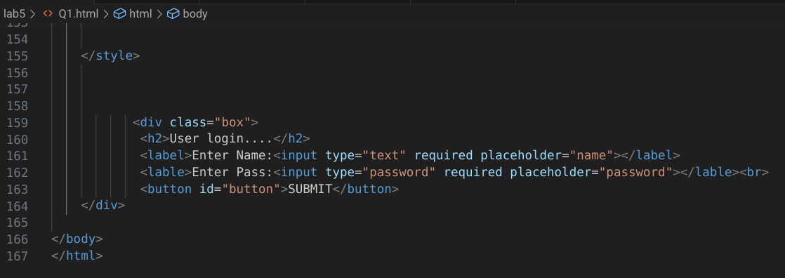

**Output:**

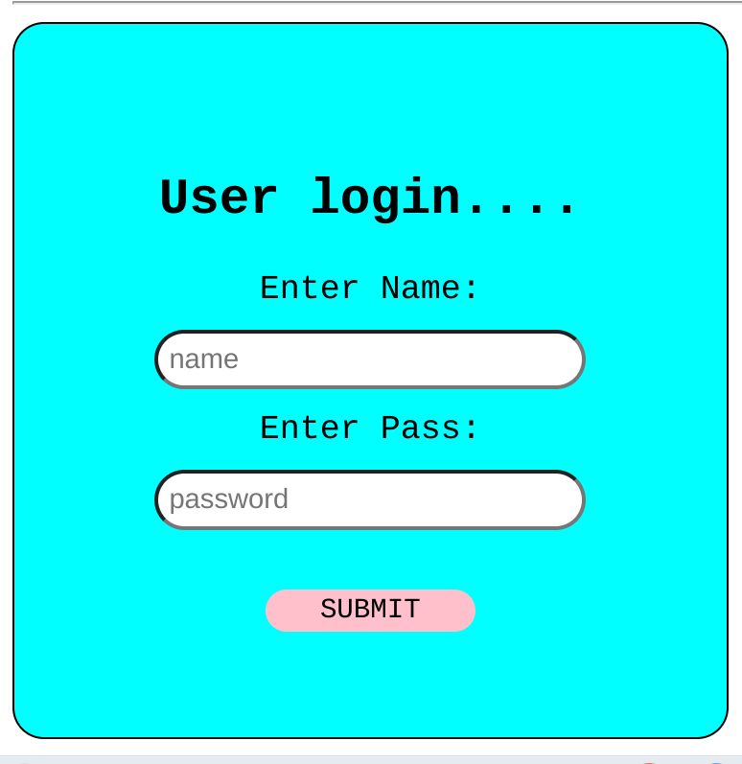

*The End*